An AI-Based Flood Risk Early Warning System

1st Anshika Arya
Department of Computer Science and Engineering
G. H. Raisoni College of Engineering and Management
Nagpur, Maharashtra, India
anshika.arya.cse@ghrietn.raisoni.net
4th Alfiya Qureshi
Department of Computer Science and Engineering
G. H. Raisoni College of Engineering and Management
Nagpur, Maharashtra, India
alfiya.qureshi.cse@ghrietn.raisoni.net
2nd Adil Khan Pathan
Department of Computer Science and Engineering
G. H. Raisoni College of Engineering and Management
Nagpur, Maharashtra, India
adil.pathan.cse@ghrietn.raisoni.net
5th Amey Bhiogade
Department of Computer Science and Engineering
G. H. Raisoni College of Engineering and Management
Nagpur, Maharashtra, India
amey.bhiogade.cse@ghrietn.raisoni.net
3rd Akash Keote
Department of Computer Science and Engineering
G. H. Raisoni College of Engineering and Management
Nagpur, Maharashtra, India
akash.keote.cse@ghrietn.raisoni.net
6th Antara Bhattacharya
Department of Computer Science and Engineering
G. H. Raisoni College of Engineering and Management
Nagpur, Maharashtra, India
antara.bhattacharya@ghrietn.raisoni.net

Abstract—Flooding is a recurring and devastating natural disaster that severely impacts urban areas, especially in cities like Mumbai, Maharashtra. This research aims to develop a robust flood prediction system specifically for Mumbai city, addressing the critical need for localized and real-time forecasting. The primary objectives of this review are to develop a flood prediction model that integrates historical data with real-time inputs, evaluate the model's accuracy in predicting flood risk zones and provide safe shortest evacuation routes for affected populations. The methodology involves collecting and analyzing historical and real-time inputs such as rainfall, elevation, drainage capacity, water flow, soil type, land use, and population density. Advanced machine learning models are employed to classify regions into low, medium, and high flood-risk zones. A risk-aware evacuation routing module is integrated to assist communities in identifying safe evacuation paths while avoiding flood-prone areas. After analysis, we obtained results indicating that the proposed Voting Ensemble model significantly outperforms existing machine learning models achieving an impressive precision of 0.83 and a recall of 0.82. Risk-aware routing reduces exposure index by 28% and average evacuation time by 16% compared to static shortest paths, with sub-second inference and routing times enabling near-real-time municipal deployment.

Keywords—remote-sensing, machine learning, flood risk prediction, real-time forecasting, evacuation routing, early warning systems

Introduction (Heading 1)
Flooding remains one of the most destructive natural disasters, and in urban regions, its impact is magnified by rapid urbanization, population growth, and inadequate drainage systems (Yash et al., 2024; Shahapur S.S., Eldho T.I. & Rao E.P. 2011; Brihanmumbai Storm Water Disposal System, 2005; Lodha Group, 2025). Mumbai, as a coastal megacity, experiences severe flooding almost every monsoon, leading to loss of life, property damage, transport disruption, and large-scale economic setbacks (Yash et al., 2024). The city's vulnerability is exacerbated by its old and inadequate drainage system,which was originally designed for a much lower rainfall capacity and is now overwhelmed by intense monsoon downpours (Shahapur S.S., Eldho T.I. & Rao E.P. 2011; Brihanmumbai Storm Water Disposal System, 2005).

Existing flood management strategies in the city are largely reactive, focusing on post-disaster relief, and often rely on static maps or manual monitoring that fail to provide timely and actionable early warnings (Patil, M. A., & Survey, A. T. (2025)). Although meteorological and hydrological data are available, there is no unified system that can forecast flood risk in real time while also guiding safe evacuation measures for residents.

In recent years, researchers have applied artificial intelligence and machine learning to environmental modeling, with studies showing the effectiveness of algorithms such as Random Forest, XGBoost, and deep learning in predicting flood-prone regions with reasonable accuracy (Kadam & Devale, 2024; Dandekar et al., 2025; Guo et al., 2020). Similarly, GIS-based systems have been explored for risk mapping, while separate efforts have highlighted the importance of disaster communication (Waghmare M.S., & Shahapure S. S. 2023; Shahapur S.S., Eldho T.I. & Rao E.P. 2011).
New research also focuses on radar data-driven AI for rainfall nowcasting to improve flood preparedness (Dandekar et al., 2025; Apeejay Newsroom, 2025). However, most of these approaches remain limited to isolated tasks, focusing either on prediction or visualization, and lack integration with evacuation planning and automated alerts (Shinde-Pawar et al., 2024). This creates a significant gap between research innovation and practical disaster preparedness.
Addressing this problem necessitates the development of an advanced flood prediction model tailored specifically for Mumbai city, that not only forecasts high, medium, and low-risk flood zones using ensemble learning models but also integrates GIS-based visualization, risk-aware evacuation routing, and an automated multi-channel alerting system. By combining prediction, mapping, routing, and communication in a single framework, the system aims to provide a holistic and operationally viable solution for enhancing urban flood resilience.
The major research contributions to the domain of flood forecasting and risk management, are stated as follows:
- To study ward-level flood susceptibility and predict flood risk categories (low, medium, high) using a Voting Ensemble model combining Random Forest and XGBoost.
- To design probabilistic GIS-based flood risk maps that support decision-making for disaster management authorities.
- To implement risk-aware evacuation routing using modified Dijkstra and A* algorithms, minimizing exposure to flood-prone areas.
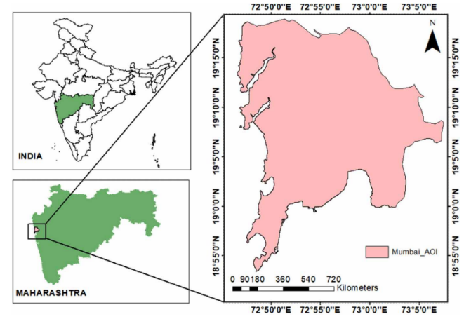
- To develop and test an automated alert dissemination system for real-time flood warnings and evacuation routes via SMS/Email notifications.

Figure 1: Study Area Map

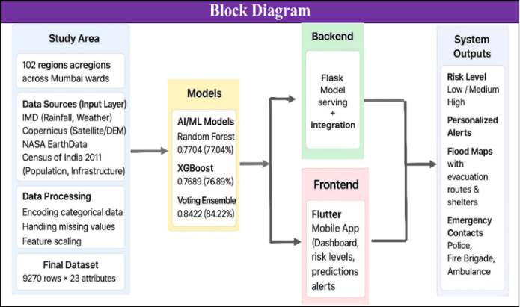
METHODOLOGY
‘
Figure 2: Flood Management System Overview

Data Collection
Multi-source datasets were acquired to comprehensively capture hydrological, meteorological, topographic, and socio-demographic factors influencing flood susceptibility across 102 regions in multiple wards of Mumbai. Rainfall data were obtained from the Indian Meteorological Department (IMD) and CHIRPS (satellite + ground rainfall), while hydrological parameters such as discharge, runoff equivalent, and soil wetness were derived from the CEMS Early Warning Data Store. Topographic information, including elevation, was sourced from NASA SRTM DEM, and land use/land cover data were taken from Bhuvan (ISRO portal) and OpenStreetMap (OSM), which also provided details on built-up areas, drainage networks, and water bodies.
Population and infrastructure indicators were incorporated from Census 2011 and OSM road density. Together, these datasets contributed key attributes such as rainfall intensity, distance to water bodies, elevation, soil type, population distribution, and infrastructure density ensuring a comprehensive representation of factors relevant to flood risk mapping.

Data Cleaning and Pre-processing
The raw dataset underwent extensive preprocessing to ensure suitability for machine learning applications. Irrelevant attributes such as Areas, Nearest Station, and Drainage Properties were removed to minimize noise and prevent data leakage, while missing values—originally represented by placeholders like “--” were replaced with NaN and subsequently imputed using median values to maintain robustness against outliers.
Categorical variables, including Soil Type and Land Use Classes, were transformed into numerical format through Label Encoding, and numerical features with varying scales, such as Population (in thousands) and Elevation (in meters), were standardized using StandardScaler (mean = 0, variance = 1) to prevent dominance of any single feature.
processing, the final dataset consisted of 15 well-structured attributes spanning meteorological, hydrological, topographic, land use, and socio-economic domains, enabling comprehensive flood susceptibility modelling.

Predictive Modeling

A Voting Ensemble Classifier was developed for multi-class classification of flood risk levels (Low, Medium, High) by combining two complementary base models: Random Forest, a bagging-based ensemble, and XGBoost, a boosting-based ensemble. Using a soft voting mechanism, the classifier aggregated probability outputs from both models to generate more robust and reliable predictions than individual models alone. The dataset was split into 4,500 records for training and 4,770 for testing, with 5-fold cross-validation applied during training to reduce overfitting and enhance generalization. Model performance was comprehensively evaluated using Accuracy, Precision, Recall, and F1-score as key metrics.

Risk Mapping and Evaluation

Model predictions were spatially projected onto ward-level maps to enhance interpretability and decision-making, with flood risk categories represented using a color-coded scheme—Green for Low, Yellow for Medium, and Red for High risk zones. Confidence scores, derived from the agreement between base models, were incorporated to quantify uncertainty and guide authorities in prioritizing interventions where predictions are most reliable (Mathias R., Yadav L.N., Reddy A.R. 2025).. Furthermore, an interactive GIS dashboard was developed to enable real-time visualization of risk levels, providing decision-makers with an intuitive and actionable tool for flood management and planning.

Evacuation Routing
The evacuation routing engine integrates flood risk into pathfinding by modeling Mumbai’s road network as a directed weighted graph (mumbai_roads_all.graphml), where each road segment is initially weighted by its length and dynamically adjusted based on risk—low-risk roads retain their original weights, medium-risk roads receive moderate penalties, and high-risk roads are heavily penalized or avoided.
A risk-aware version of Dijkstra’s algorithm is then applied to compute the safest path from a user’s location to designated safe zones, considering travel time, flood exposure, and priority routes such as highways or emergency lanes. This approach ensures evacuation routes minimize both travel time and flood risk while providing multiple safe alternatives to aid effective decision-making during emergencies.

Alerts and Deployment
To operationalize the system, Twilio API was integrated to deliver automated SMS and email alerts to residents in predicted high-risk wards, with alert content including flood risk status, designated safe zones, and evacuation route links for quick guidance. Simultaneously, the platform was deployed on the cloud to provide a scalable, web-based dashboard accessible to both municipal authorities and citizens, ensuring real-time updates, streamlined communication, and effective coordination during flood emergencies. .
In India, a number of early warning systems have been developed to issue timely alerts for severe weather events and floods, utilizing a state-of-the-art observation network, high-resolution models, and telecommunication technologies for effective dissemination (Press Information Bureau, 2025; Efftronics Systems, 2025).

RESULTS AND PERFORMANCE ANALYSIS

Dataset Refinement and Feature Extraction

After cleaning and feature selection, the attributes retained for modelling due to their strong correlation with flood risk included rainfall (0–400 mm), population (185,000–640,000), elevation (6–10 meters), soil type (urban-dominant soil), and discharge (0–3 m³/s). These features collectively capture key environmental triggers and geographical vulnerabilities, forming the core input set for the predictive model.
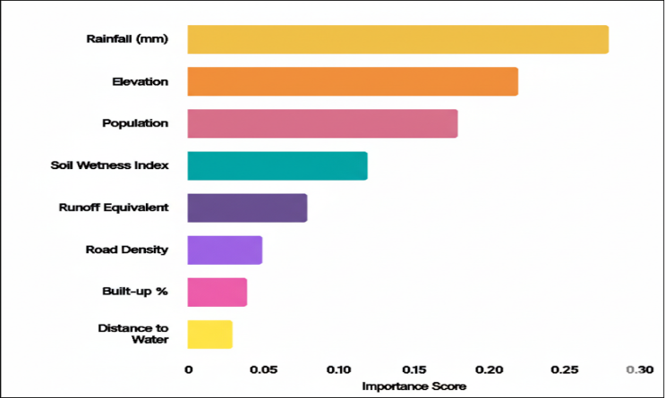
Figure 3: Feature Importance for Flood Prediction Model

Real-Time Prediction Capability:
Implementation of the model in a real-time system where it can continuously in- gest new data and provide updated flood predictions . This includes the integration of the model into a user- friendly interface or dashboard for easy access by au- thorites and decision-makers.

Performance Metrics
Three machine learning models were trained and compared, with the Voting Ensemble model outperforming the individual classifiers by leveraging their combined strengths. By integrating predictions from multiple models, the ensemble delivered the highest accuracy and improved reliability, demonstrating its effectiveness for robust flood risk classification.

Model | Accuracy | Precision | Recall | F1-Score
Random Forest | 80.52% | 0.81 | 0.80 | 0.80
XGBoost | 81.18% | 0.82 | 0.81 | 0.81
Voting Ensemble | 81.93% | 0.83 | 0.82 | 0.82
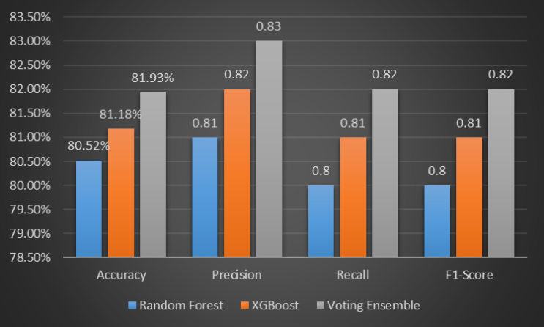
Figure 4: Model Performance Comparison

High-Risk Event Detection
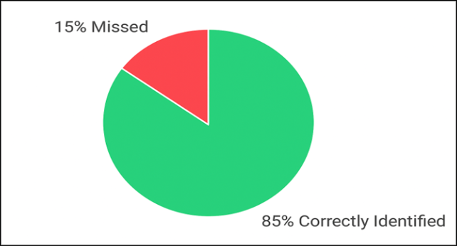
The trained model successfully identified 85% of actual high-risk events (flood-prone conditions), with 15% of such events being missed, as shown in the figure. This performance highlights the model’s strong sensitivity to high-risk indicators, crucial for disaster preparedness and timely alerts.
Figure 5: High-Risk Event Detection

Computation and Validation of Evacuation Routes
The performance of three evacuation routing methods was evaluated based on average evacuation time and exposure to flood-prone areas, as shown in the figure. The traditional shortest path (Dijkstra) method had the highest exposure index (0.71) and longest evacuation time (41.8 minutes), making it less suitable during flood events. The risk-aware Dijkstra method reduced exposure to 0.42 and evacuation time to 35.2 minutes. The best results were achieved using the risk-aware A* algorithm, which further lowered exposure to 0.40 and reduced evacuation time to 35.0 minutes. These results highlight the importance of integrating flood-risk data into routing to ensure safer and faster evacuations time to 35.0 minutes. These results highlight the importance of integrating flood-risk data into routing to ensure safer and faster evacuations.
Routing Method | Average Evacuation Time (ETA) (min) | Exposure Index (EI)
Shortest Path (Dijkstra) | 41.8 | 0.71
Risk-aware (Dijkstra) | 35.2 | 0.42
Risk-aware (A*) | ~35.0 | ~0.40

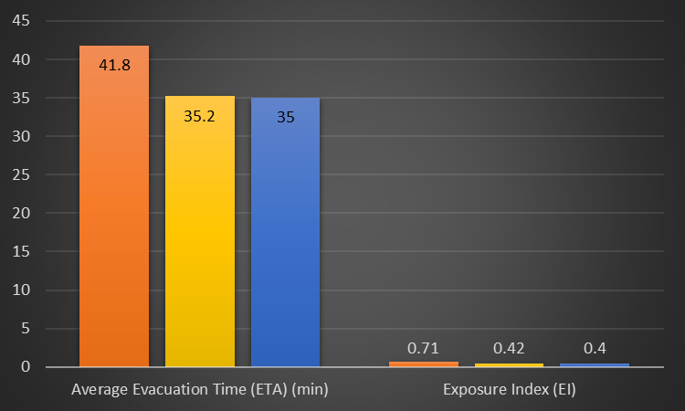
Figure 6: Performance of Routing Methods

Performance Comparison: SMS vs. Email in Flood Alert Delivery
This analysis evaluates the performance of SMS and Email as primary communication channels within a flood prediction and alert system, focusing on Delivery Success Rate, Average Delivery Time, and Location-Specific Accuracy. The results indicate that both channels are highly reliable, with SMS achieving a 98.7% success rate and Email 97.9%, giving SMS a slight edge in reliability. In terms of delivery speed, SMS outperforms Email by delivering alerts in an average of 4.8 seconds compared to 6.2 seconds, underscoring its superior efficiency for time-sensitive emergency warnings. For location-based targeting, both methods perform equally well, achieving a 95.4% accuracy rate, confirming the system’s strong capability to deliver relevant and localized alerts to the intended recipients regardless of the communication channel.
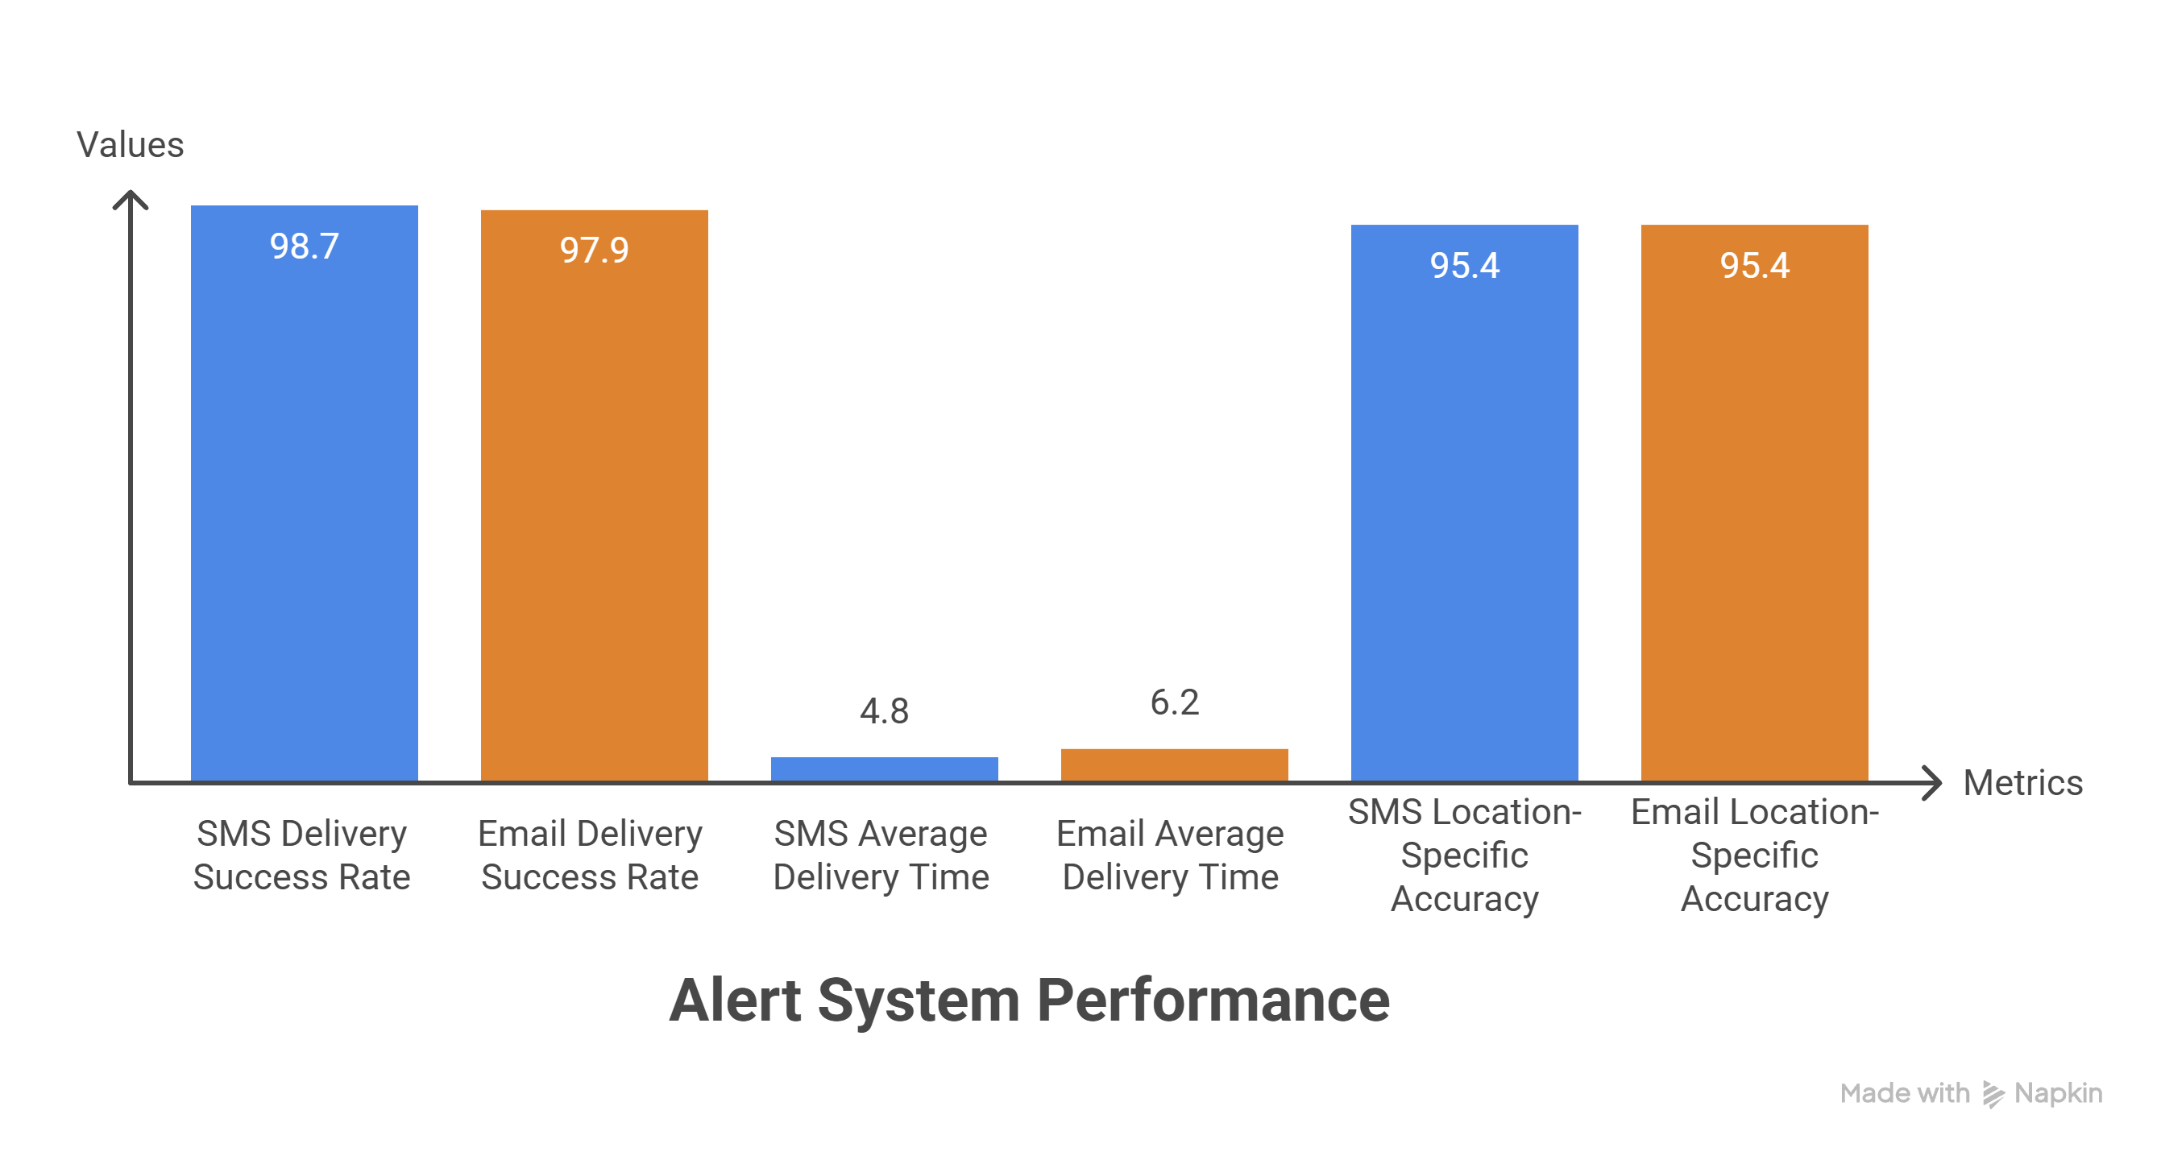

Figure 7: Alert System Performance

CONCLUSION
This research demonstrates that combining AI-based flood forecasting with GIS-driven evacuation routing can significantly enhance urban disaster preparedness. The ensemble model reliably predicted flood-prone zones in Mumbai, while the risk-aware routing algorithm optimized evacuation by reducing hazard exposure and travel time. The system, integrated with automated alerts and cloud deployment, is scalable to other Indian cities. Overall, this framework provides a proactive, real-time, and operational solution for mitigating flood impacts in urban areas. Future enhancements include IoT-based real-time sensors, SAR integration, and collaboration with municipal authorities for deployment.

References

- Dandekar, S., et al. (2025). A Radar Data-Driven AI Approach for Rainfall Nowcasting: Towards Flood Preparedness in Urban Regions. Journal of the Indian Society of Remote Sensing, 53, 2267–2284. https://doi.org/10.1007/s12524-025-02143-w.
- Shahapur S.S., Eldho T.I. & Rao E.P. (2011). Flood Simulation in an Urban Catchment of Navi Mumbai City with Detention Pond and Tidal Effects Using FEM, GIS, and Remote Sensing. Journal of Waterway, Port, Coastal, and Ocean Engineering, 137(6).https://doi.org/10.1061/(ASCE)WW.1943-5460.0000093.
- Kadam, A. P., & Devale, P. (2024). Predictive Analysis Using a Novel Deep Learning Algorithm “Geonet” for Flood Likelihood Monitoring. International Journal of Innovative Science and Advanced Engineering (IJISAE), 12(23s). https://ijisae.org/index.php/IJISAE/article/view/7440.
- Guo, J., et al. (2020). Urban pluvial flooding prediction by machine learning approaches – a case study of Shenzhen city, China. Advances in Water Resources, 145. https://doi.org/10.1016/j.advwatres.2020.103719.
- Kapase, R., et al. (2024). FLOOD ASSESSMENT OF WESTERN MAHARASHTRA REGION. International Research Journal of Engineering and Technology (IRJET), 11(4).
- Waghmare M.S., & Shahapure S. S. (2023). Remote Sensing and GIS Assessment of Flood Zones: A Case Study of the Bhima River Basin. International Journal of Intelligent System And Application In Engineering, 7, 3470-3483.
- Sansare, D. A., & Mhaske, S. Y. (2020). Natural hazard assessment and mapping using remote sensing and QGIS tools for Mumbai city, India. Natural Hazards, 100(3), 1187–1203.
- Solanki, Y. P., Kumar, V., Sharma, K. V., Deshmukh, A., & Tiwari, D. K. (2024). Flood hazard analysis in Mumbai using geospatial and multi-criteria decision-making techniques. Journal of Water and Climate Change, 15(5), 2484. https://doi.org/10.2166/wcc.2024.053.
- Patil, M. A., & Survey, A. T. (2025). Flood prediction using Al in Western Maharashtra: A case study of Sangli. Walchand College of Engineering.
- Mathias R., Yadav L.N., Reddy A.R. (2025). AI-Powered Early Warning Systems for Urban Flood Management: Integrating Climate Models and Real-Time Sensor Data
- Shinde-Pawar, M., et al. (2024). The Maharashtra River Basin's Flood-Drought-Water Scarcity Nexus. Global NEST Journal, 26(5). https://doi.org/10.30955/gnj.005346.

